Here's the install guide for the AMSS header... do this at your own
risk... It is preferred that you have a professional install this for
you, as it is a bit complex, and you have to drop the engine cradle. I
take no responsibility in damage to your car, parts, and/or yourself.

Tools Needed:
- big ass ratchet
- small ratchet
- extensions for ratchets
- various sized sockets ranging from 10-19mm
- 12mm wrench
- torque wrench
- jack & jackstands or hydraulic lift
- flathead screwdriver
- 2 nuts that will fit on the bolts that attaches the manifold to the
downpipe/cat
- BEER!
- the strength of the incredible hulk, or air tools

Step1 - Lift car, remove bottom plastics
Start off by lifting up the car, and putting it on jackstands.... be
smart... don't work under your car w/the risk of it falling on you.
Once the car is up, pull off your engine plastics.
I'm not gonna get into how, because if you can't do that, you shouldn't
be installing this header.

Step2 - Remove manifold bracket
Now it's time for the fun stuff... let's start taking crap apart!
remove the 2 bolts and 1 nut holding the stock manifold bracket... make
sure it doesn't fall on you, it's heavy enough to at least chip a tooth.
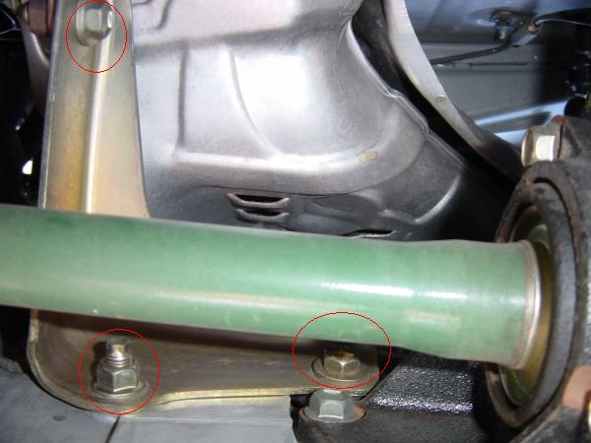

Step3 - Undoing the flange that connects to the cat
Undo the flange that connects the stock manifold to the catalytic
converter pipe, they're the 2 circled bolts... it's just like unbolting
your exhaust ;)
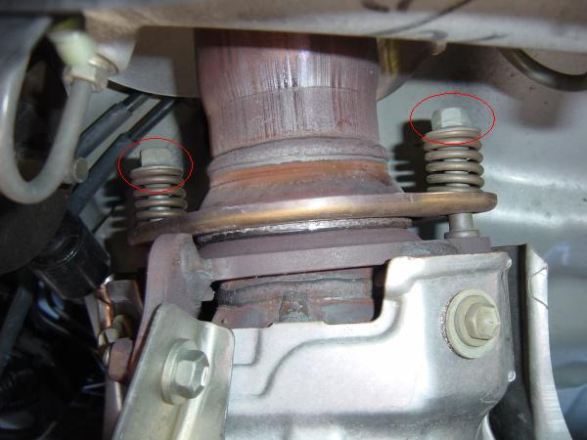

Step4 - pulling the heatshields off
*note* you may need to remove your front strut bar to get tools back
behind the engine... do this w/the car on the ground.
Let's start by unbolting the bottom heatshield.
You'll either be using the wrench here, or a ratchet depending on the
bolt... they're in places that are pretty tight and can only be gotten off w/a wrench for a few of em.
Pull off these bolts... the heatshield should be loose once that's done
(bottom one)
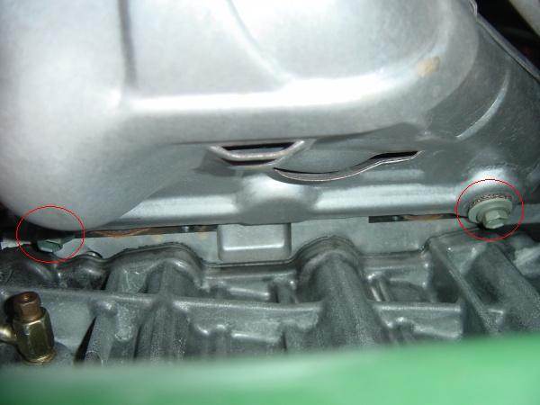
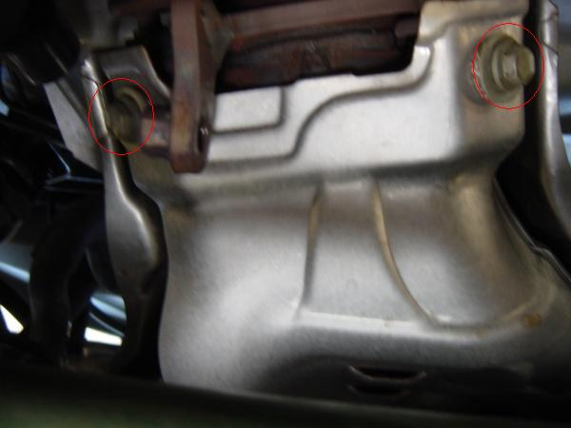
(top one)
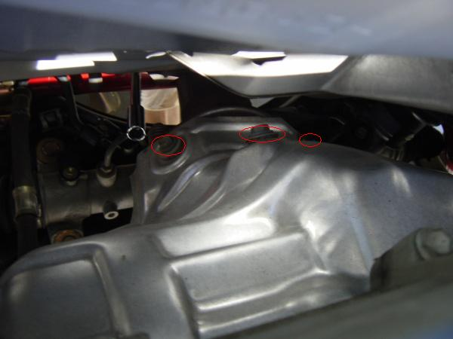
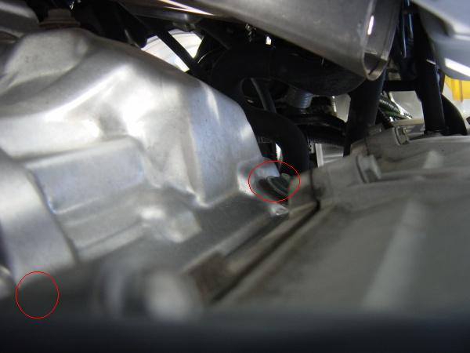
note: there are 4 on the bottom heatshield, 5 on the top heatshield

Step5 - Pull that badboy off the engine
Now it's time to unbolt the stock manifold from the engine.
There's 2 nuts and 1 bolt above the pipes, 2 bolts underneath...
Some of them are tricky to get to, so you may need to use some short
socket extensions, and/or flex joints for your ratchet.
(view from the bottom)
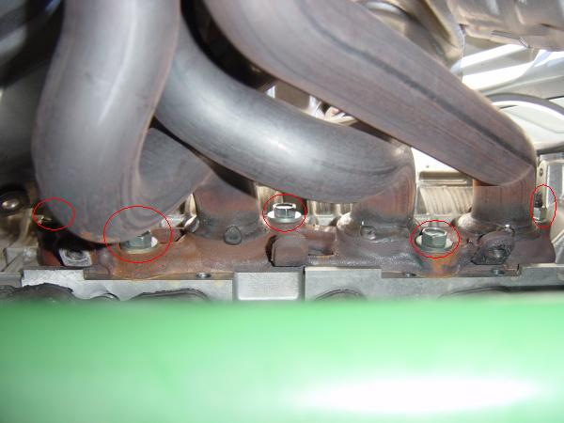

Step6 - Getting it all out of your engine compartment
This is the alltime mother of a bitchwhore step in the whole install.
It's been said that it can come out the bottom just as it is now, but I
spent about 4 hours flipping, and turning, etc etc everything to try and
get it out... well... it didn't happen, so I had to remove the engine
cradle (or at least clear up another inch or so in the opening)
what I did:
(warning - you should support the engine/engine cradle w/some jacks to
make sure neither falls on you)
(bolts are circled in the picture)
remove all bolts/nuts from front->back crossmember (including front
engine mount
loosen the bolts on the driver side of the cradle
remove the bolts from the passenger side
undo the bolts for the rear engine mount
now, w/all of this loos, you can pull the engine cradle towards the back
of the car, and you should have enough room to pull out the stuff.
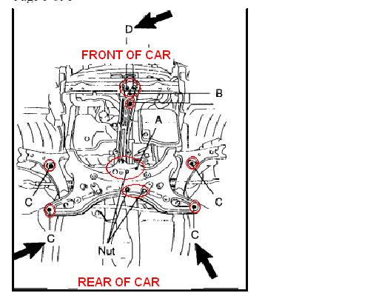
make sure to retorque these to manufacturer specs later on.

Step7 - wow... that's the difference
here, you drink a beer, look at the two manifolds side by side, chill
for a minute, etc...
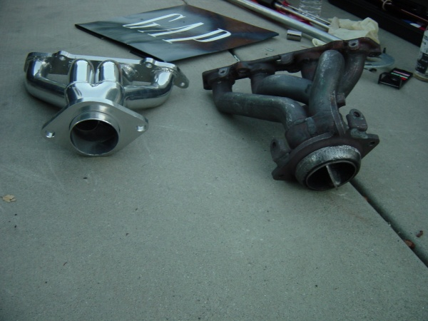

Step8 - Putting stuff back in
Now, you gotta put everything back together.
You must pull off the O ring from the stock manifold and put it on the
new header so you can get a good seal. Also, you need to put the stock
gasket on the bolts sticking from the engine where the manifold bolts
to.
Put the new header in, line it up w/the holes, and tighten it up.
On the engine side, it's the 3 bolts and 2 nuts, on the exhaust side,
use the springed bolts, but you will need new nuts for it since they
bolt directly into the stock manifold.
Once all this is done, and tightened well, start putting the engine
cradle and the stuff that you removed on step 6.
You will not be putting the heatshields nor the manifold bracket back
in.

Thathatha that's all folks!
Now that it's done, reset the ecu, start up the car, and cross your
fingers.... you should be good to go.. hopefully, without any leaks.
I thought I had an exhaust leak, but it was just the sound of the inside
of the engine coming through the new header since it's stainless steel,
not cast iron.
Here's what it looks like installed.
