This is a copy of a install sheet provided from TRD USA, I do not take responsibility for any damages that may occur when installing this product.
(TRD REV 0 6/12/00)

Please follow the instructions carefully.
Please do not throw away the instructions. Keep them with the vehicle for future use.
** corresponds to the color code and can be found on the box label:
TRD USA Part Number
00602-08150-1**
Toyota Genuine Part Number
08150-20190-**
A0 Super White (040)
B0 Liquid Silver Metallic (1D0)
C0 Black (202)
C1 Carbon Blue (210)
D0 Absolutely Red (3P0)

Materials/Tools/Parts
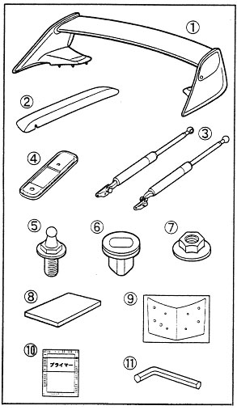 | Parts  Tools  10mm Box Wrench  10mm Socket  Torque Wrench  Screwdrivers (both kinds)  Tape (Shipping, Duct, etc)  Ruler (metric)  12mm and 14mm Step Drill Bits  Vacuum or Magentic Pickup Tool  Pilot Hole Punch  3mm and 9mm Drill Bits  Cylindrical File  Alcohol  Adhesion Promoter  Tape Measure (metric)  Toyota Touch up Paint(Body Color)  Heat Gun or Blow Dryer
  No | Description | Part Number | Qty.
  1 | Wing |  | 1
  2 | Lens Cover |  | 1
  3 | Trunk Damper |  | 1 / side
  4 | Retainer |  | 2
  5 | Bolt | 68961-20140 | 2
  6 | Clip |  | 4
  7 | Nut | 90179-06129 | 4
  8 | Foam Pad |  | 1
  9 | Template |  | 1
  10 | Cleaning Pad |  | 1
  11 | Allen Wrench (5mm) |  | 1

Instructions
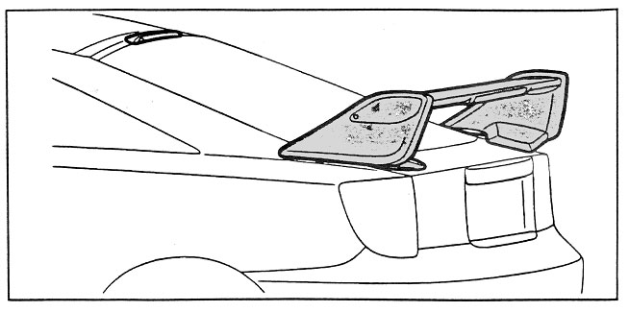

1 - Disassembly of Factory Parts
a) Disconnect Ground Terminal of the battery.
b) Pull out Rain Gutter Access Plug. Pull the factory connectors out of the hole. See Figure 1. Pull out the factory 8 pin connector.
CAUTION - Do not pull the wires too hard or too far. The wires are connected to a harness with other functions
c) Disconnect the connectors.
d) Find the Green-White wire from the small 2 pin female connector and the Green-White wire on the 8 pin female connector. We are merely going to swap this set of wires.
e) Get or make a terminal tool that conforms roughly to the dimensions shown in Figure 2a.
f) Lift the terminal retainer on both connectors. You will need to remove some of the foam to access the retainer.
g) To remove a pin, slide the tool in between the pin and the locking lug from the connection side of the connector. Pull the wire out. To install a pin, simply slide the pin in from the wire side of the connector until it locks.
h) Remove the Green-White wire from the 8pin connector. Remove the Green-White wire from the 2 pin connector and insert this wire into the 8 pin connector. Insert the other wire into the 2 pin connector.
i) Connect the 2 pin connectors and wrap them connected with the provided foam. Stuff the wiring and connectors back into the hole and seal the hole tightly with the rain gutter access plug.
j) Remove the grab pocket and the screw which holds it in.
k) Remove the trunk interior cover panel. It is held on by 10 clips.
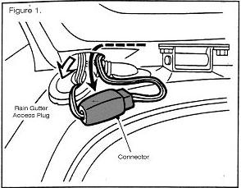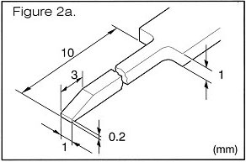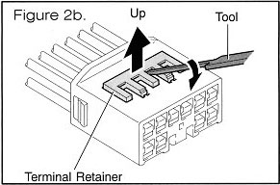
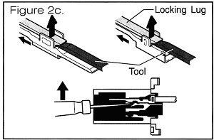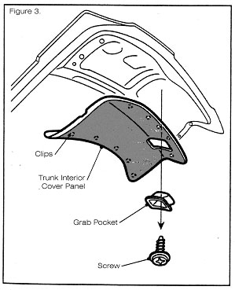

2 - Drilling
a) Cut the supplied template in half and discard the shaded region.
b) Apply templates to the trunk lid. On the sides, align the template to the edge of the trunk lid. At the rear, align the template to the extent of the flat section. Tape them down.
c) Punch pilot holes as depicted in the template. There are 9 holes. If the car had a factory wing, line up the 9mm holes in the template with the factory wing holes.
d) Drill 3mm holes in these pilot holes. Note that cars equipped with factory wings will not require drilling at the 4 factory holes. If the vehicle does not have a factory wing, drill the 4 9mm holes.
e) Drill the 4 12mm holes.
f) Drill the 14mm hole.
g) If the vehicle had a factory wing, place the new wing on the vehicle and push down so that the studs in the trunk lid can make an impression on the new wing. Using the drill stopper, the drill, and a 9mm drill bit, drill into the new wing to make room for the studs.
Tip - Use a drill stopper to prevent drill more than 5mm. See Fig. 6.
h) Deburr with the file the edges of all of the holes.
i) Remove the pieces of tape covering the holes in the trunk. Use the vacuum or the magnetic pickup tool to pickup all of the metal chips both in and around the trunk.
Caution - Remove all of the chips as they will rust.
j) Apply touch up paint to cover the exposed metal from the holes.
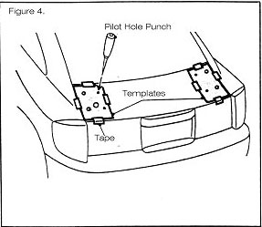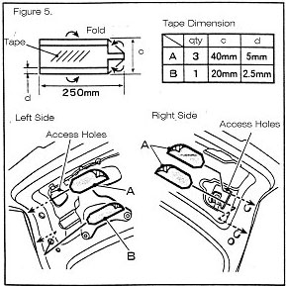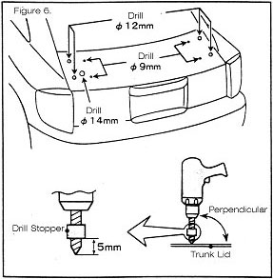

3 - Dampers
Caution - This section is only for those cars which do not have factory installed wings. If you have a factory wing, please proceed to Section 4.
a) Pull off the factory damper by pulling the socket off the upper end of the damper and unbolting the bracket on the lower end of the damper. Replace the factory ball jointed bolt with the supplied ball jointed bolt.
b) Put on the new dampers by connecting the ball joints. Put thread lock on the threads of the 4 bolts which hold the bracket to the frame of the vehicle. Bolt the bracket to the vehicle and tighten all 4 bolts.
c) Make sure that all of the connections and bolts of the damper assembly are tight.
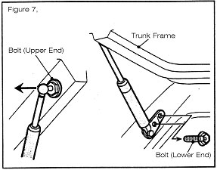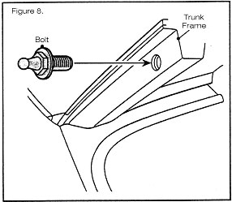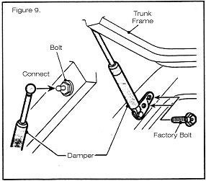

4 - Installation
a) Clean the shaded region with the supplied cleaning pad and alcohol. Remove all of the oils and waxes.
b) Insert the four supplied clips into the 12mm holes.
c) Remove the tape covering the part of the wing that will meet the trunk lid.
d) Pass the brake light wiring through the 14mm hole. Seat the rubber grommet snug in the hole.
e) Push the wing down into position. The studs will seat in the 4 clips which sit in the 12mm holes.
Tip - Push down on the uprights to ensure the wing is seated solidly
f) Pull the connector through the access hole.
Caution - Be careful when you reach into the holes as there may be sharp metal edges.
g) Install the retainer as shown in Figure 14. Put on the 4 supplied nuts and tighten. If the vehicle had a factory wing, it already has a retainer welded into the trunk lid. The supplied retainer is not needed and can be thrown away.
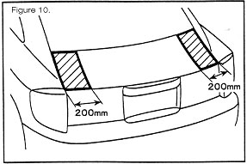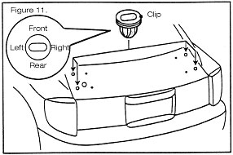
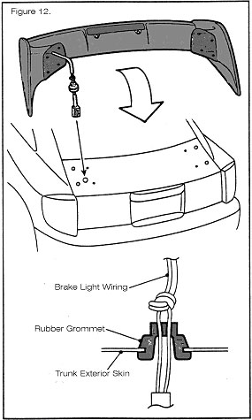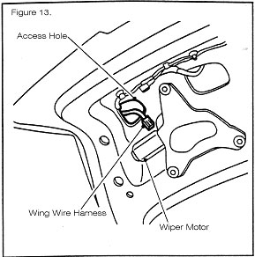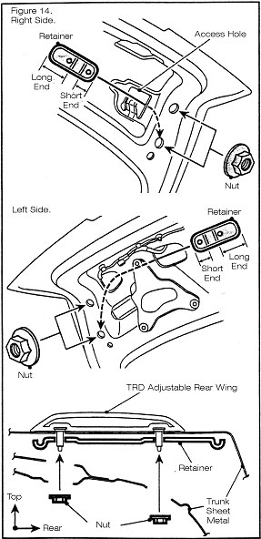

5 - Hi Mount Brake Light Cover
a) Connect the factory connector for the wing to the connector from the wing.
b) Clean the shaded area around the factory hi mount brake lens with the cleaning pads and alcohol.
c) Pull off a tab of the adhesive cover from each of the adhesive strips. Do not remove the entire adhesive cover.
d) Place the lens cover over the hi mount brake light and align as shown in figure 16.
e) Hold the lens cover in place and pull away the adhesive cover.
f) Push down on the lens and heat the area with the heat gun or blow dryer. A little bit of heat will strengthen the hold of the adhesive. Do not heat too much as the paint and the lens cover may become damaged.
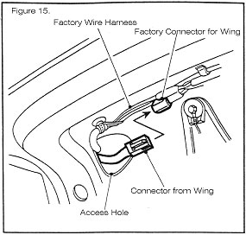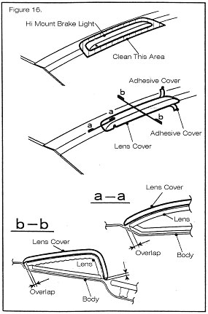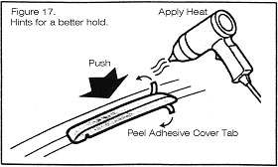

6 - Replacing the Factory Trim
a) Replace the trunk interior cover.
b) Replace the grab pocket. Secure it with the factory screw.
c) Reconnect the ground terminal on the battery

7 - Double Checking the Fit
a) Push the wing forward and back, left and right to make sure that the wing is not loose.
b) Press the brake pedal to make sure that the hi mount light works.
c) Check the trunk dampers. Make sure that the trunk opens smoothly and stays up.
d) Make sure that the horizontal portion of the wing is not loose.
Congratulations. We hope you enjoy all of the quality and thoughtfulness we have strived to provide you.
(uhh... interesting line in the instructions... dontcha think?) - Russ

ADJUSTING THE WING ANGLE
a) Remove the allen bolt on both sides. Remove the covers.
b) Loosen, but do not remove the rear side bolts.
Caution - Hold the wing as removal of the front side bolts will allow the wing to rotate.
c) Remove the front side bolts.
d) Hold and tilt the wing to the desired angle and line up the holes of the metal plate and the holes in the wing. Insert the front side bolts and tighten.
e) Tighten the rear side bolts.
f) Replace the covers and tighten the allen bolts.
